**Influencers SQL Queries**

**KPIs**

1. **Total Followers**

SELECT SUM(CAST(REPLACE(REPLACE(followers, 'm', '') , '.', '') AS BIGINT)) AS total_followers

FROM influencers;

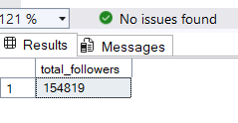

1. **Average Engagement Rate:**

SELECT AVG(TRY_CAST(REPLACE([_60_day_eng_rate], '%', '') AS FLOAT)) AS avg_engagement_rate

FROM influencers

WHERE [_60_day_eng_rate] IS NOT NULL AND [_60_day_eng_rate] <> '';

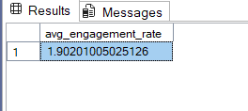

1. **Average Likes per Post:**

SELECT

SUM(

CASE

WHEN total_likes LIKE '%k' THEN TRY_CAST(LEFT(total_likes, LEN(total_likes) - 1) AS FLOAT) * 1000

WHEN total_likes LIKE '%m' THEN TRY_CAST(LEFT(total_likes, LEN(total_likes) - 1) AS FLOAT) * 1000000

WHEN total_likes LIKE '%b' THEN TRY_CAST(LEFT(total_likes, LEN(total_likes) - 1) AS FLOAT) * 1000000000

ELSE TRY_CAST(total_likes AS FLOAT)

END

) /

SUM(

CASE

WHEN posts LIKE '%k' THEN TRY_CAST(LEFT(posts, LEN(posts) - 1) AS FLOAT) * 1000

ELSE TRY_CAST(posts AS FLOAT)

END

) AS avg_likes_per_post

FROM influencers;

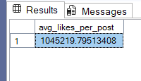

**4. Average Influence Score by Country**

SELECT country, AVG(TRY_CAST(influence_score AS FLOAT)) AS avg_influence_score

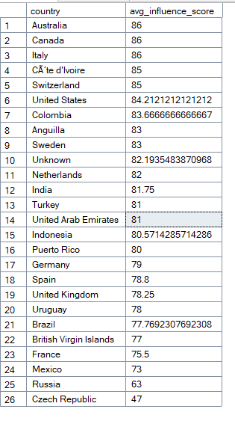FROM influencers

GROUP BY country

ORDER BY avg_influence_score DESC;

1. **Country with the Most Influencers :**

**SELECT TOP 1 country, COUNT(*) AS total_influencers**

**FROM influencers**

**GROUP BY country**

**ORDER BY total_influencers DESC;**

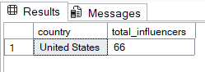

Creating Calculated Fields

**🔹 1. Engagement Rate (ER)**

**Formula:** ([avg_likes] / [followers]) * 100

This metric standardizes how engaged an influencer’s audience is, relative to their follower count.

SELECT

channel_info,

TRY_CAST(REPLACE(avg_likes, 'm', '') AS FLOAT) * 1000000 AS avg_likes_num,

TRY_CAST(REPLACE(followers, 'm', '') AS FLOAT) * 1000000 AS followers_num,

(TRY_CAST(REPLACE(avg_likes, 'm', '') AS FLOAT) * 1000000) /

(TRY_CAST(REPLACE(followers, 'm', '') AS FLOAT) * 1000000) * 100 AS engagement_rate

FROM influencers

WHERE avg_likes IS NOT NULL AND followers IS NOT NULL;

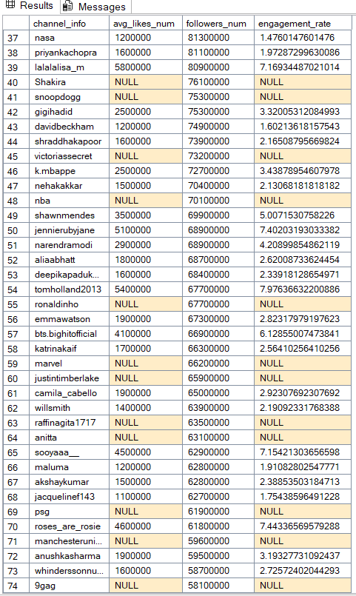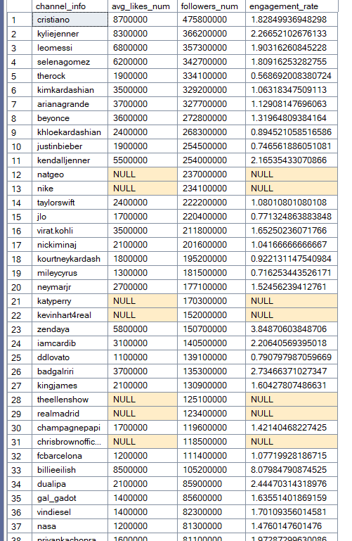

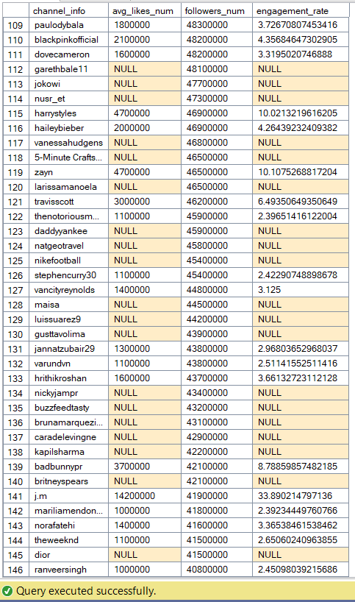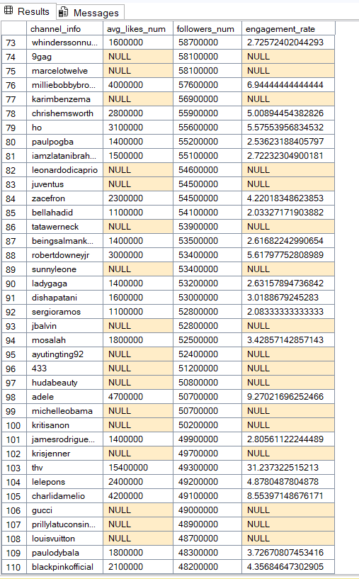

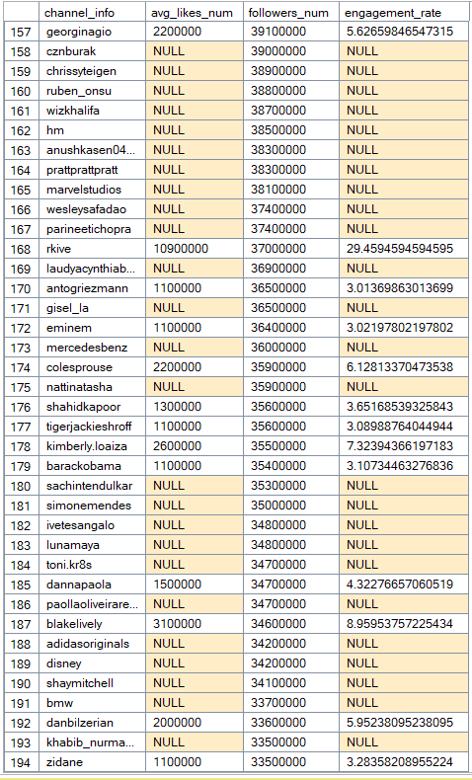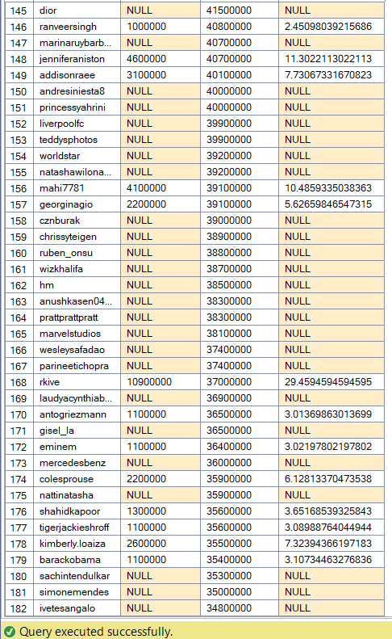

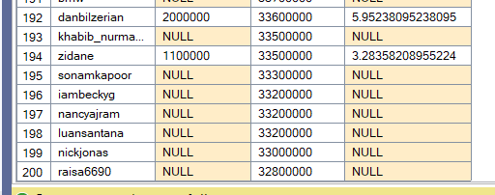

**🔹 2. Growth Rate in New Post Likes**

**Formula:** ([new_post_avg_like] - [avg_likes]) / [avg_likes] * 100

This shows whether their likes are increasing or decreasing in recent posts.

**✅ SQL Query:**

SELECT

channel_info,

TRY_CAST(REPLACE(new_post_avg_like, 'm', '') AS FLOAT) * 1000000 AS new_likes,

TRY_CAST(REPLACE(avg_likes, 'm', '') AS FLOAT) * 1000000 AS old_likes,

((TRY_CAST(REPLACE(new_post_avg_like, 'm', '') AS FLOAT) -

TRY_CAST(REPLACE(avg_likes, 'm', '') AS FLOAT)) /

TRY_CAST(REPLACE(avg_likes, 'm', '') AS FLOAT)) * 100 AS growth_rate

FROM influencers

WHERE new_post_avg_like IS NOT NULL AND avg_likes IS NOT NULL;

OUTPUT

THIS IS HYPER LINK

**🔹 3. Like-to-Follower Ratio**

**Formula:** total_likes / followers

Used to understand long-term performance — total engagement relative to audience size.

**✅ SQL Query:**

SELECT

channel_info,

TRY_CAST(REPLACE(total_likes, 'b', '') AS FLOAT) * 1000000000 AS total_likes_num,

TRY_CAST(REPLACE(followers, 'm', '') AS FLOAT) * 1000000 AS followers_num,

(TRY_CAST(REPLACE(total_likes, 'b', '') AS FLOAT) * 1000000000) /

(TRY_CAST(REPLACE(followers, 'm', '') AS FLOAT) * 1000000) AS like_to_follower_ratio

FROM influencers

WHERE total_likes IS NOT NULL AND followers IS NOT NULL;

OUTPUT

THIS IS HYPER LINK